Mana Surge: The Green Puzzle
Zvi Mowshowitz
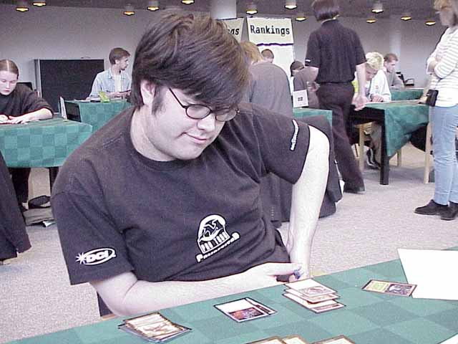
Lots of people are avoiding green in Invasion drafts. Why? What went wrong with green in Invasion? The short answer is it has too many mana cards and they crowd out everything else, meaning that where we would normally see a big creature, we see Quirion Trailblazer, where normally there would be a Giant Growth-type spell, there is Harrow; the rest of the article is the long answer. Here's a list of the green commons in the set:
Green:
Aggressive Urge
Explosive Growth
Fertile Ground
Harrow
Kavu Climber
Llanowar Cavalry
Llanowar Elite
Llanowar Vanguard
Nomadic Elf
Pincer Spider
Quirion Elves
Quirion Sentinel
Quirion Trailblazer
Serpentine Kavu
Thornscape Apprentice
Tranquility
Vigorous Charge
Wandering Stream
Whip Silk
Gold containing Green:
Armadillo Cloak
Frenzied Tilling
Llanowar Knight
Yavimaya Barbarian
There's something wrong with this set of cards. Green has nineteen commons, plus two red/green and two white/green. If you were to play only green, you would lose a lot of useful picks to Fertile Ground, Harrow and Quirion Trailblazer (since you wouldn't be using their mana-fixing abilites). Nomadic Elf, Quirion Sentinel and Quirion Elves would be significantly weakened. Thornscape Apprentice would go to waste. Then you have to throw out the cards that aren't main deck quality: Llanowar Elite, Llanowar Vanguard, Vigorous Charge and Wandering Stream. Whip Silk and Tranquility are generally considered border line filler. That leaves only eight commons from which to form the core of your deck.

If you were to play only green, you would lose a lot of useful picks
You have Pincer Spider, which is great for blocking flyers, and Llanowar Calvary to help with the ground. Explosive Growth and Aggressive Urge are decent combat tricks, with the Urge often giving you card advantage, but you definitely have to watch out for a mana glut with the Urge, as you'll see later on. Then there's the core of the deck: You get two solid big creatures. Kavu Climber is a great deal at 3/3 and a card for five mana, and can be really depressing to play against; it didn't cost you a card and often they'll be scrambling to trade with it. Serpentine Kavu is a 4/4, which is pretty big in this format. To back those up, you get two two power creatures for two mana, the Quirion Sentinel and Nomadic Elf. And that's it.
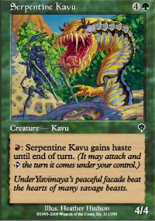
Green's Machine
If you add another color, green obviously gets better. Counting all the relevant gold cards, green allows white to add in the amazing Armadillo Cloak and the solid Llanowar Knight and gain most of the benefits from the Thornscape Apprentice. On the white side, Sunscape Apprentice gets better, if still rather marginal, and you transform Rampant Elephant from a bad card into a solid one. You also get everything white has to offer. But the point here is that green still nets you only five additional non-mana commons here. On the other side, suppose you added red. The Thornscape Apprentice goes from unplayable to marginal. Frenzied Tilling can be cast, but it's still basically another mana card. Yavimaya Barbarian is basically the same as Llanowar Knight, a solid creature but nothing special. Serpentine Kavu gets a little better, but it was already good. Savage Offensive gets to turn surprisingly savage at times, despite the fact that most people are ready to toss the card in the trash the moment they see that it's a sorcery. Thunderscape Apprentice becomes a decent card, and Viashino Grappler gets a tiny bit better. Being generous, that's also five additional non-mana commons, one of which (Thornscape Apprentice) is overlap.
So at most, green grants thirteen non-mana commons you can be happy playing if you stick to two colors, and seventeen if you go with both allied ones, and that counts the Sentinel and Nomadic Elf. By contrast, white has twelve cards I would be happy with in a mono-white deck, and adding green gets you the same five overlap cards while adding blue would give you four and greatly strengthens at least three additional cards you were already playing. Again, the Apprentice is the one card that overlaps. Blue has thirteen playable commons alone, black has fourteen and red only has nine but a lot of that is removal. Adding additional colors produces similar compound effects.

Taking a big risk in a draft can be a very good idea. If it works it works. If it fails, it fails.
Why the emphasis on non-mana playable commons rather than just playable commons? It illustrates an important aspect of deckbuilding. You can have all the mana you want, and it's certainly going to be a big help if you can consistently and quickly cast your spells, but it's the non-mana spells that are going to actually win you the game. This is even truer in Limited, because you will almost never be able to use mana acceleration to finish someone before he or she can get off the ground. It does happen, but normally it's more because of a mana stall or otherwise poor draw on the other side than because of your amazing start. The exception right now would probably be the quick abuse of Frenzied Tilling, since it allows you to destroy their land, but unless you're using it to get off color mana, it's clearly a pale shadow of old fashioned land destruction like Stone Rain. Casting Stone Rain on turn three is easy, requiring only three land plays. Casting Frenzied Tilling on turn four would be considered fast, and given that you already have five mana that sixth land isn't normally all that important except when you need it for its color. When you're playing four or five colors in Limited, getting the right mana cards becomes extremely important, but when you're still within two or two and a splash they're basically just a nice touch.
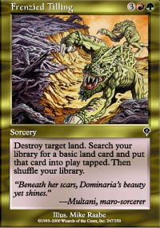
The key is you need to have twenty-three (or sometimes twenty-two if your cards are expensive, sometimes one or two less if your mana's really weird) non-mana playable cards, and have them come together to form a deck. There are various concerns you need to deal with in that distribution. You have to watch your mana curve, but still make sure you have enough raw power. You have to make sure you have enough tricks, and that enough of those tricks are removal. You have to make sure you have enough creatures. You have to make sure you can deal with the ground and can deal with flyers. Even if you deal with all those separate concerns, it still needs to come together into a deck with a strategy and a plan. With a good plan, you can often compensate for a problem in one of those areas, sometimes even more than one. Creature count in particular is a concern that I think many players pay too much attention to. Having a lower than normal creature count means that your creatures become more valuable; you can no longer trade them automatically for your opponent's creatures, because you might run out. You also end up using removal and other tricks more freely to make up for the gap. It's a pretty complex issue, and probably a whole additional article.

Drafting a deck using green as a base is often a disaster.
The goal of a well-balanced deck full of solid cards is much more difficult than usual when working from such a depleted card pool. Most good drafts will finish with a few more playable cards than you have room for, but no more. That standard solid draft goes from a safe bet to a very risky one with the reduction in the card pool. The fact that a lot of the solid green cards you do get are two power creatures makes things even worse. Then add in the lack of removal or flying and green starts looking risky.
In short, drafting a deck using green as a base is often a disaster. There are two options. One is to draft a deck that isn't solid; instead, the deck goes beatdown. The second option is to play three or more colors. The beatdown option is the last chance to get a green deck with a normal mana base. It wouldn't be anything that hasn't been drafted with previous sets. Using red as the second color, a mana curve is worked out that allows the deck to take advantage of the mana problems and mana curve holes and cantrips of other draft strategies, backing up fast creatures with pumping effects like Explosive Growth and red removal. This deck's biggest advantage is that many of its best cards are considered, for good reason, to be 'bad' cards. No one else wants them. Green's mana isn't amazingly useful without additional colors but it still helps out if there's a random power card to splash or just to get the jump on the opponent.

In the Top 8, it's better to draft a 3-0 deck or a 0-3 deck than to get a 2-1 deck every time.
Many players that traditionally like to draft beatdown decks tried this out as one of their earliest strategies. Almost everyone with drafting experience from previous sets tried this deck out to see how it was. It's definitely one of the standard decks in the format; if no one else at the table is trying for it then it will often be quite decent. Early on, when I was trying this deck out to see how good it was, more than one person I played against said more or less "oh, another mindless red/green deck." After playing a few of them, it was hard to disagree. The deck got better or worse depending on how well the draft went; I got varying degrees of burn and pumping effects and mana curves and creatures of varying quality. But it came down to the same thing. I cast my dudes, attack with my dudes and ask if I just won.
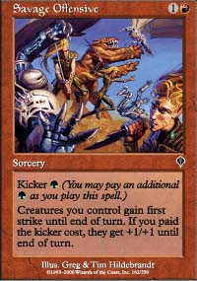
Green/red beatdown thrives on cards that seem suboptimal
In addition, these decks can be good but they have a very hard time being great. There's only so much that can be done with even the most efficient attackers and removal. The best cases generally involve the deck having more burn than it has any right to have. But when a blue/black or blue/white or even black/red deck is really on their game, they'll play big creatures the removal can't hit and kill the creatures that threaten them with removal or tap them or Shackles them or even just counter them with Exclude. As usual, the 'classic battle' of control against beatdown comes down to the quality of the control deck. These beatdown decks are reasonable, but are definitely a fall back position.

Drafting 5cG is a radical departure from drafting a normal deck.
Then there's Five Color Green (5cG). Drafting 5cG is a radical departure from drafting a normal deck, but in essence, all that's happening is an expansion of the card pool in exchange for an additional element that must be in that 'well balanced deck.' Everything that had to be in the deck still has to be in it, but in addition to that, the deck needs to ensure that it has colored mana. That means picking up cards like Fertile Ground and Harrow, and picking them up early. The difference between needing mana and needing something else is that whether the deck gets its mana will determine what its card pool is. Either mana cards must be drafted early and often before drafting the off-color cards, or the entire draft could fail if the mana doesn't show up later on when it should.
That's one of the two problems with the Five Color Green strategy. Both answers to the question are bad. If early picks are used up to get the mana, then that means passing up the power cards that make drafting the deck worthwhile in the first place, aside from the cards that are based on controlling basic land types. This way of drafting is basically a trade:

Give up the early picks for the first pack and probably the second one (and sometimes the third) and in exchange a lot of cards get much better, some of which (like Strength of Unity and Ordered Migration) are often very late picks but to you become pure gold. You also get the literal gold cards. The other way is to draft the cards first and then pick up the mana later. As was noted before, that's a gigantic gamble. Without the mana, the deck will be worthless. But especially at a PTQ, taking a big risk in a draft can be a very good idea. If it works it works. If it fails, it fails. Better to draft a 3-0 deck or a 0-3 deck than to get a 2-1 deck every time.
The other flaw is also because of the mana, and it takes several forms. The first is the obvious one: To play five colors is to invite mana screw. Because several of the best cards for insuring five colors of mana require basic lands (including the best one, Harrow), the deck is going to start off with one land in each of the three minor colors. Hopefully, green will be the primary color of the deck, white or red will probably be the secondary one and the other three will be minors. A distribution of 8 Forest, 5 Plains, 2 Island, 1 Swamp and 1 Mountain is troublesome; three or four of each would be a disaster. These extra basic lands make it difficult to have enough of each land type without playing too many lands. Decks tend to have requirements from each color. One deck might have enough black to require ten Swamps and enough blue to need seven Islands. Another might need only eight of each, leaving a choice on the last land. A third might have very mana intensive cards, and even in two colors have to cheat a little on its color requirements.

To play five colors is to invite mana screw.
Then these basic lands have to be complemented. For a more or less ideal set of mana cards, say the deck can run two Harrow and a Fertile Ground, and has two copies of Nomadic Elf. This means that if the deck has one Mountain as its only other source of red, there will be six sources of red mana. Six sources of a color is worrisome for an important color but fine for running a Plague Spores, a Breath of Darigaaz and a Tribal Flames. It's unlikely that the deck will get caught with more than one uncastable red spell, and it's impossible to get stuck with more than one Mountain. An additional problem might be the extra mana needed to use Nomadic Elf. Trying to cast Plague Spores in particular might be a problem. Seven mana is significantly higher than six, and the source you would normally use for red mana might also be needed for black if it isn't Harrow. And taking Plague Spores happens to be one of the things Five Color Green mages like to do. Overall, the deck will definitely be less stable than one using only two colors. If, in the course of a match, the deck always has the right mana for its spells, it got lucky. With a worse set of mana producing cards, things get rapidly worse.
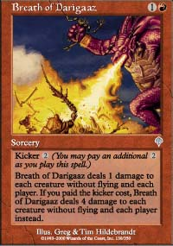
When there is enough mana to cast all the deck's spells, the opposite issue comes up. Are there enough spells? Too often the answer will be no. Being generous, sixteen lands will be needed to consistently cast Harrow, so add three pure mana sources outside those sixteen to about two creatures that are just 2/2 or 2/1 except for the mana they provide, and the majority of the deck is gone with only two small creatures to show for it. Putting pressure on your opponent's land with Frenzied Tilling and Plague Spores can be devastating, but in the long term only makes the problem with having enough 'cards that count' even worse.
Still, some players like Five Color Green. It allows the drafting of almost any card at almost any time, and it's great to cast Ordered Migration, Exotic Curse and Tribal Flames for five each. But the conclusion I've reached is that this deck isn't something anyone should be sitting down hoping to draft. It is the best chance for someone forced into green that either cannot or does not want to go into a red/green mindless beatdown plan. It's also a fallback position for someone forced out of their early colors or who receives off-color bombs they cannot pass up. If this deck is drafted, its limitations must be understood.
What does the future hold for green? The best guess is that things will get better with Planeshift and Apocalypse. The problem right now is an overload of mana cards. With only one pack of Invasion, the supply is divided by three. Then Five Color Green goes back to being difficult to pull off and maybe goes back to a strategy worth trying for early on, White/Green and Red/Green return to being able to draft solid decks, and the mana goes from a problem to an asset. By itself, Harrow is golden.

